ENERGY GUIDED NOTES:

What do you already know about energy?

WHAT IS ENERGY?

- Energy is an abstract concept like love or freedom and is difficult to define…
- Energy: Scientists define energy as the ability to exert a __________, do ___________ or cause change. (The ability to make things happen!)

WORK IS ENERGY IN ACTION

- Work= force x distance
- W = fd
- When you exert a force and move an object over a distance, you have done work
- Work is measured in Nm or joules

THE TWO MAIN CATEGORIES OF ENERGY (all other energy forms can be sorted into these two groups)
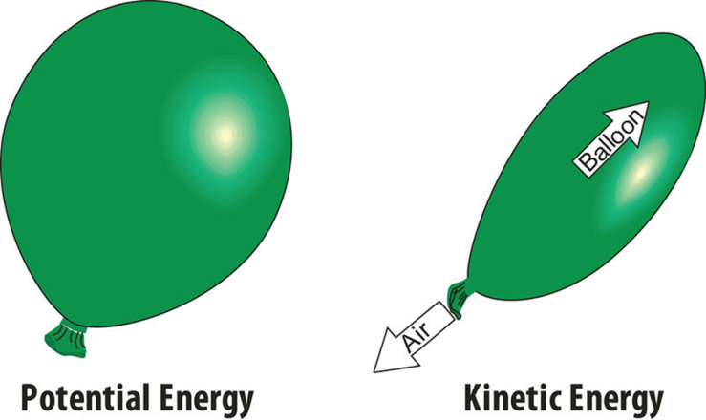
- Kinetic Energy: energy of ____________

- Potential Energy: _____________ energy

KINETIC ENERGY
- This is energy of motion.
- Kinetic energy is the motion of :
  - ANYTHING including
  - Waves
  - Electrons ( negatively charged particles in ___________)
  - Atoms (the smallest component of an element having the chemical properties of the element )
  - Molecules (The smallest unit of a substance that has all of the physical and chemical properties of the substance )
  - Eureka – Kinetic Energy
  - https://www.youtube.com/watch?v=39ga-TGXOwM&index=6&list=PL07249EFA9038FDC1
POTENTIAL ENERGY

- This is ___________ energy that is capable of producing motion.
- Examples: draw and explain!!!

- Meter stick + ball
- Newton’s Cradle

3 Other Examples discussed in class:

- 2. 3.

CALCULATING PE

- You can calculate potential energy by calculating the ___________ you did raising the object up against gravity – or you can use the equation

Potential energy = mass x gravity x height
or
- PE = mgh

- Remember: g = 9.81 m/s2

EXAMPLE CALCULATIONS IN CLASS:

PE =
PE =
PE =

LAW OF CONSERVATION OF ENERGY

- Energy cannot be created or destroyed, it only changes form.
- Within a closed system, the total amount of energy is constant.
  - Closed system: nothing gets in or out
  - Ex. sealed chamber
    - Universe
- Is the Earth a closed system?
- Newton’s Cradle

